Expectation | Entering | During Instruction | Finished Early with Work | Group Work | Restroom/ Break | Have a Question
Be Safe
Be Respectful
Be Responsible
Be Your Best
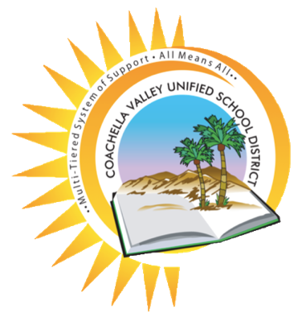
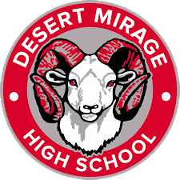
Classroom Expectations
Desert Mirage High School
The Ram Promise

